Checkpoint Bible Camp
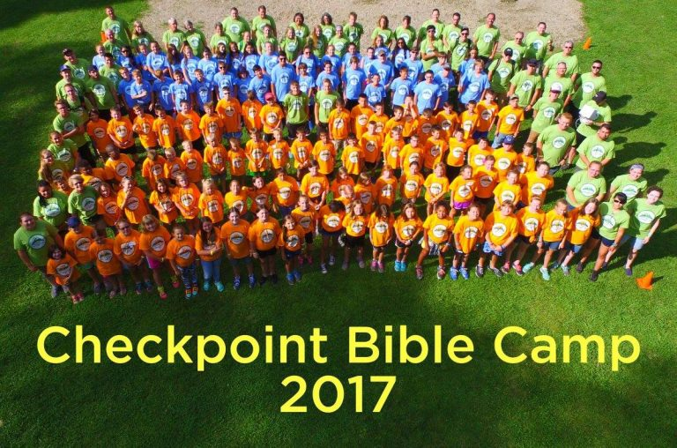

2018

Portage Bible Church
Pastor Ron Smith
(Camp Administrator)
2748 Willowdale Rd.
Portage, IN 46368
219-762-8951

April 1, 2018

Dear Churches,

It is that time of year again, the time to start planning for Checkpoint Bible Camp! We are excited to see God use this opportunity to continue to offer a biblical, fun, and cost effective camp right here in our area. The camp will meet at Camp Buffalo near Monticello, IN on July 23rd through July 27th, 2018. Please use the enclosed information to promote camp. One registration packet is provided and can also be copied as needed. These forms, promotional video and other information can also be found at
www.ifcaindiana.org/blog/ Follow the Checkpoint tab on the left corner, click on 2017 media then 2018 promo video to present this 2 minute video to your congregation

The camp pastor this summer is Pastor Chris Allen of Heritage Bible Church in Remington, and the camp activities directors are Pastor Ben Nagel of Portage Bible Church in Portage, IN and Pastor Josh Mc Carnan of Bethel Bible Church in Winamac, IN. Pastor Ray Laborde of McCoy Memorial Baptist Church in Elkhart is serving as our camp facility coordinator. We are anticipating a great week of camp with 80 Junior campers and about 40 Middle School campers! Make sure to log onto our Checkpoint Bible Camp Facebook page to check out what’s going on as it happens.
PLEASE NOTE – Camp operates on Eastern Time!

Blessings,
Pastor Ron Smith
Camp Administrator

